Template-Driven Forms & Validation
Task 1: Build the Enrollment Request Form
Goal: Create a template-driven form with multiple input types and ngModel bindings.
Generating the enrolment-form
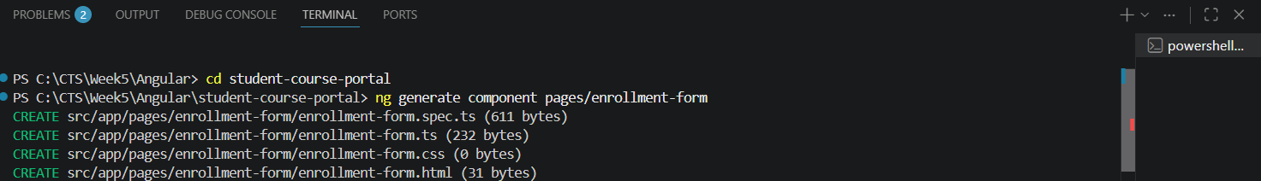

Enrolment-form.ts:
Building the form with values
Declaring onSubmit function and Logging the data in the console

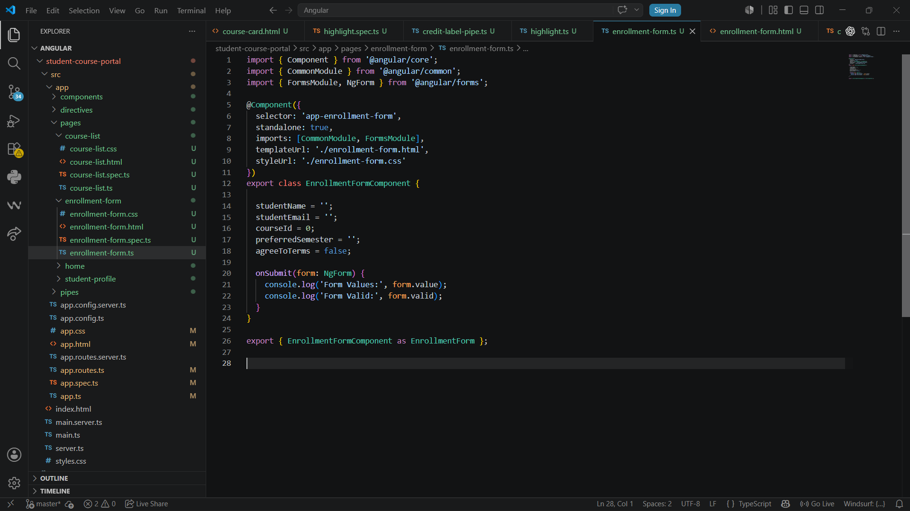
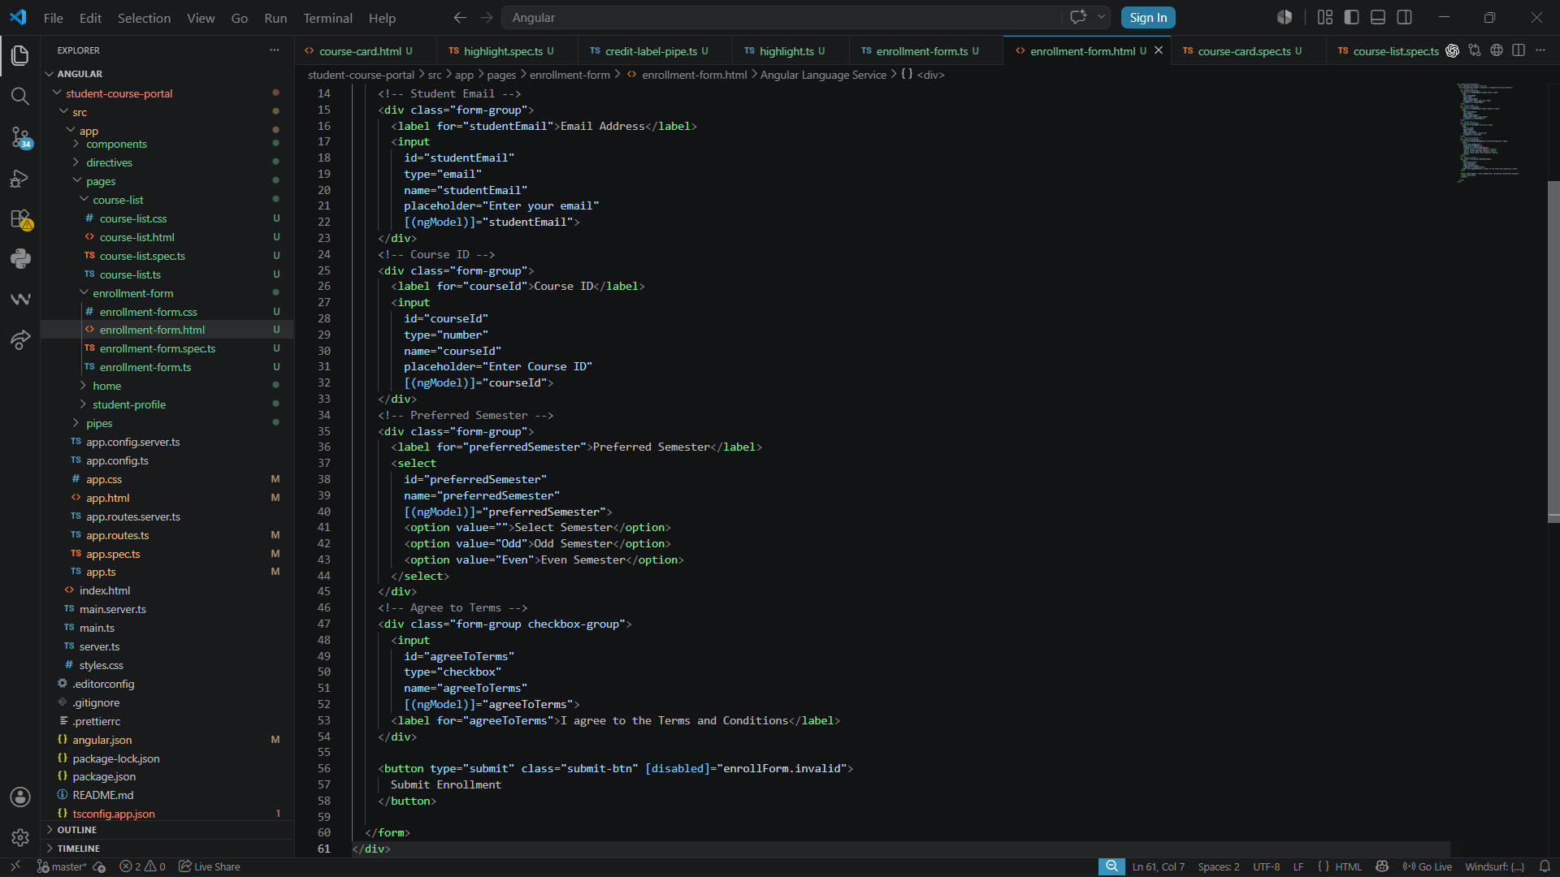

Output:

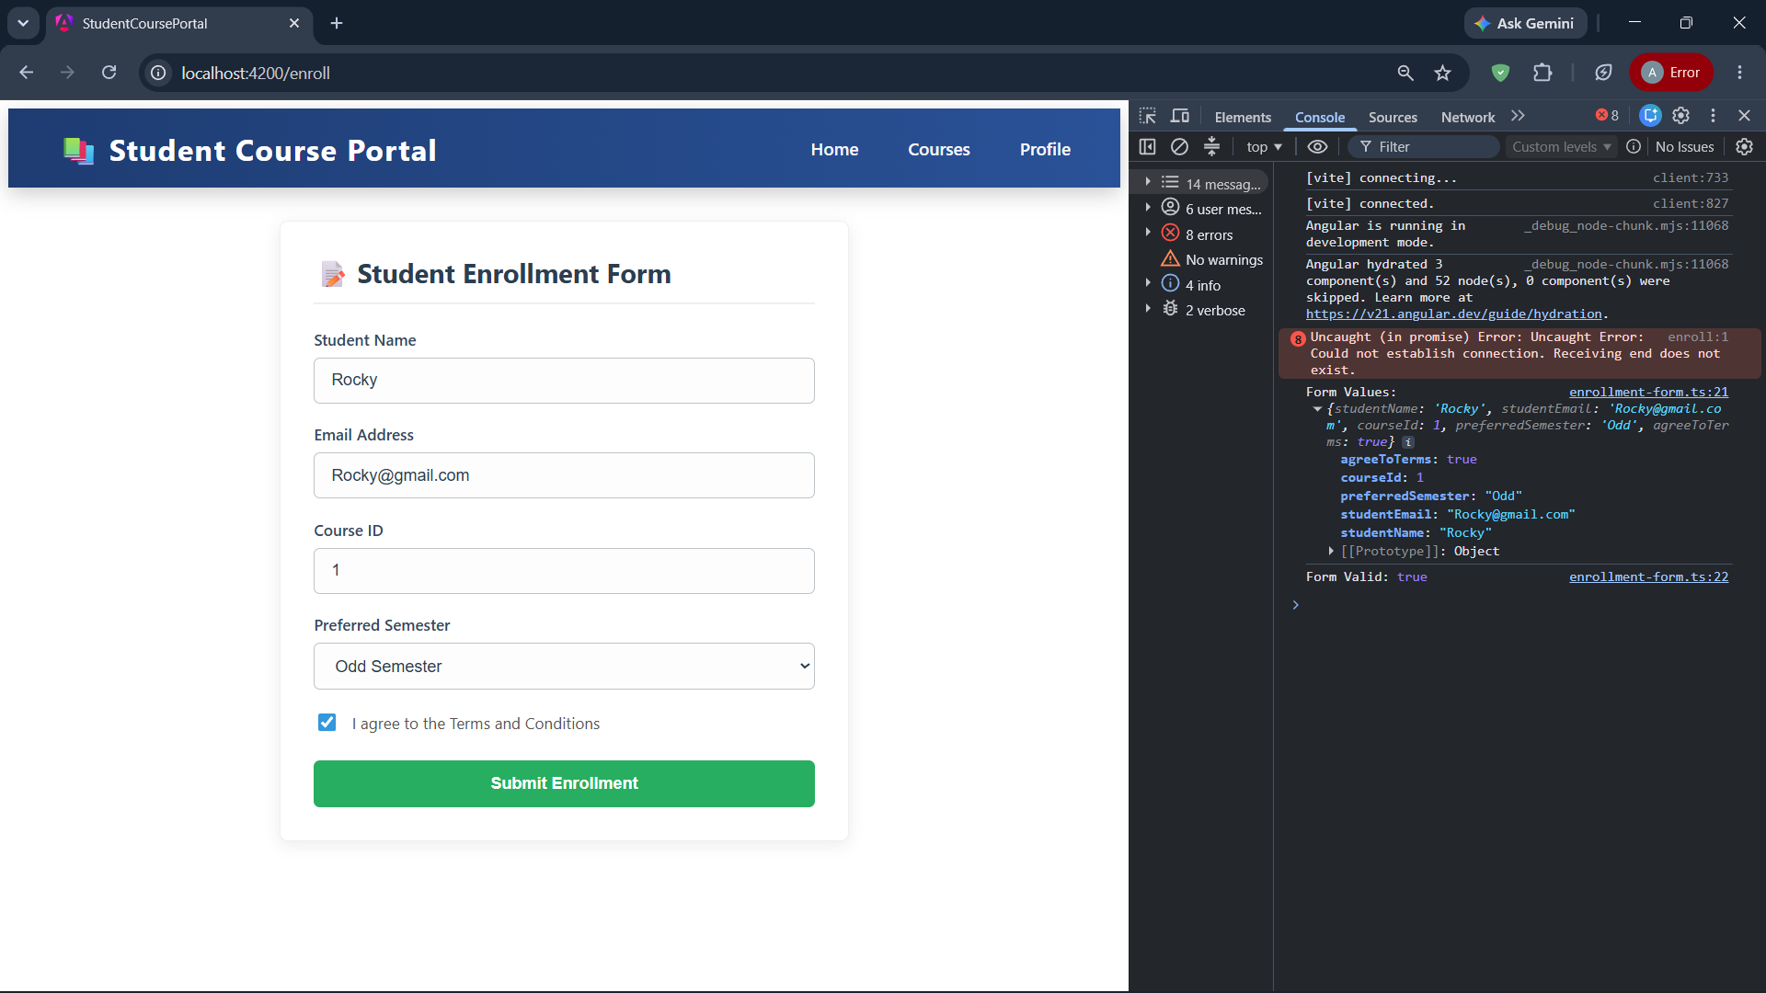

Task 2: Validation and Error Messages
Goal: Add built-in validators and display contextual error messages for each field.

Enrolment-form.html:
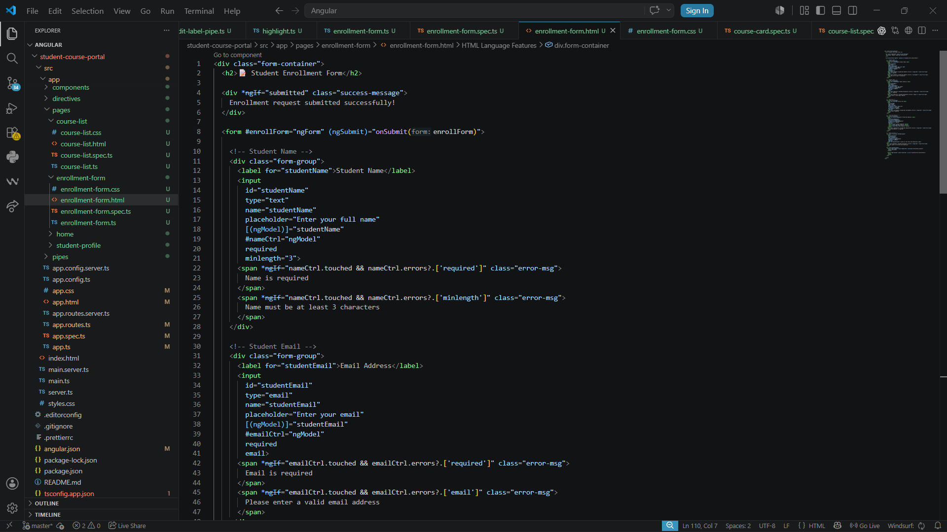

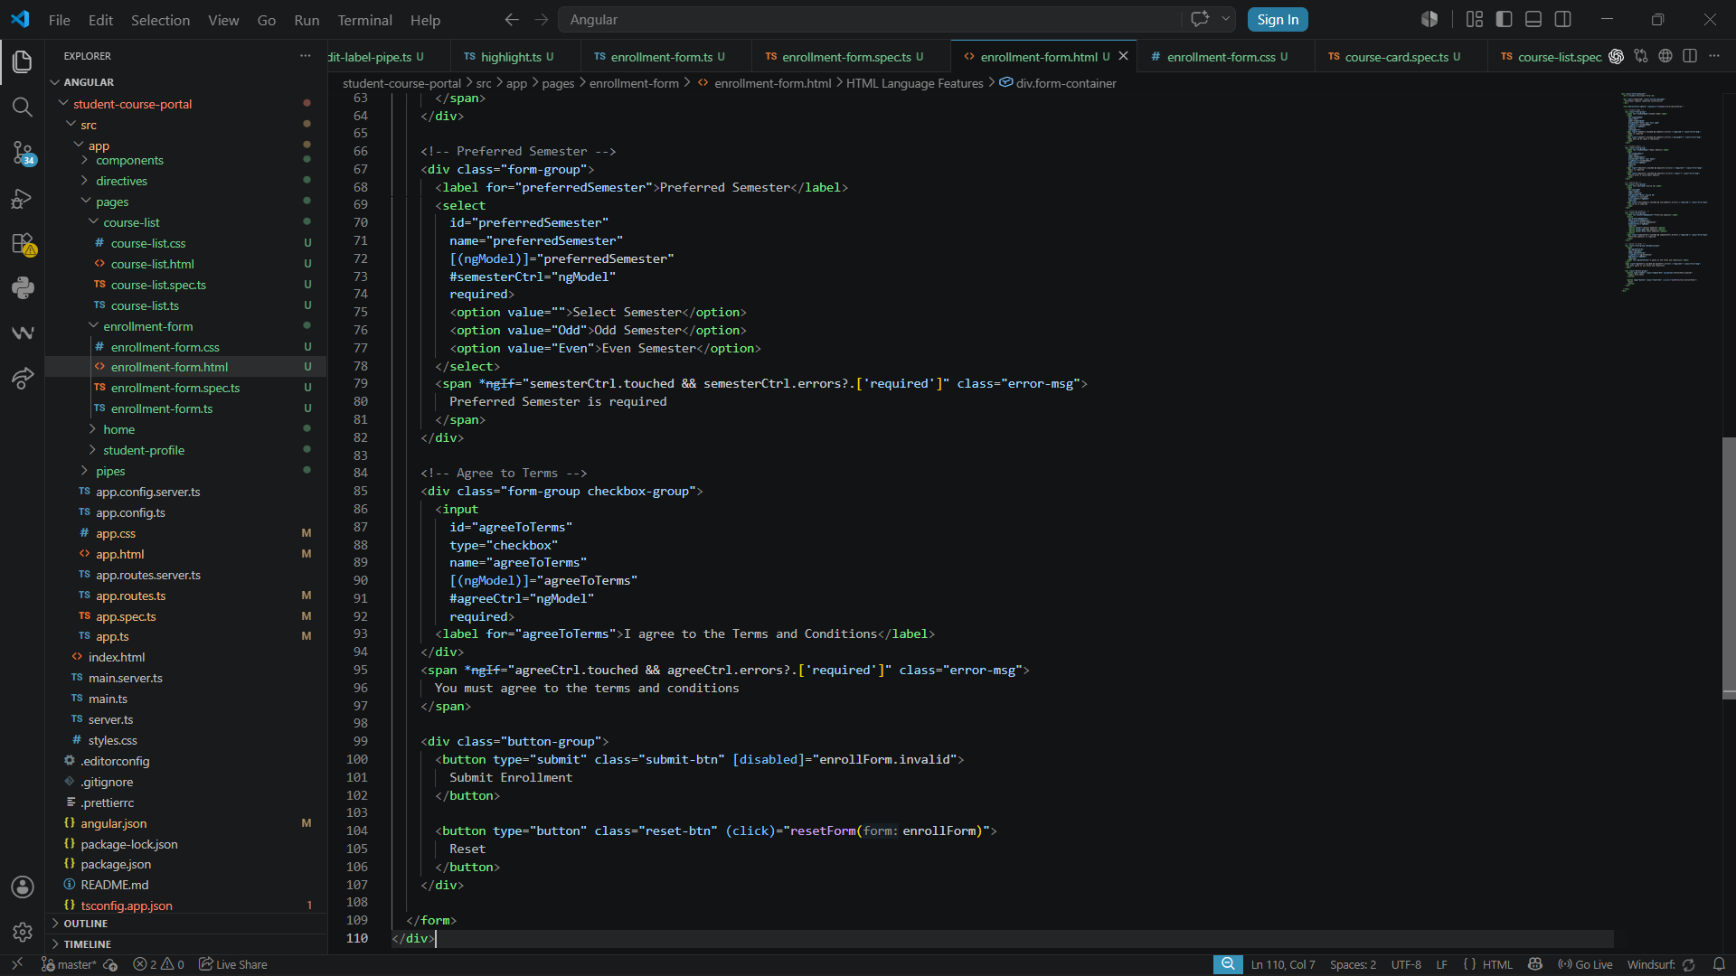

Enrolment-form.ts:
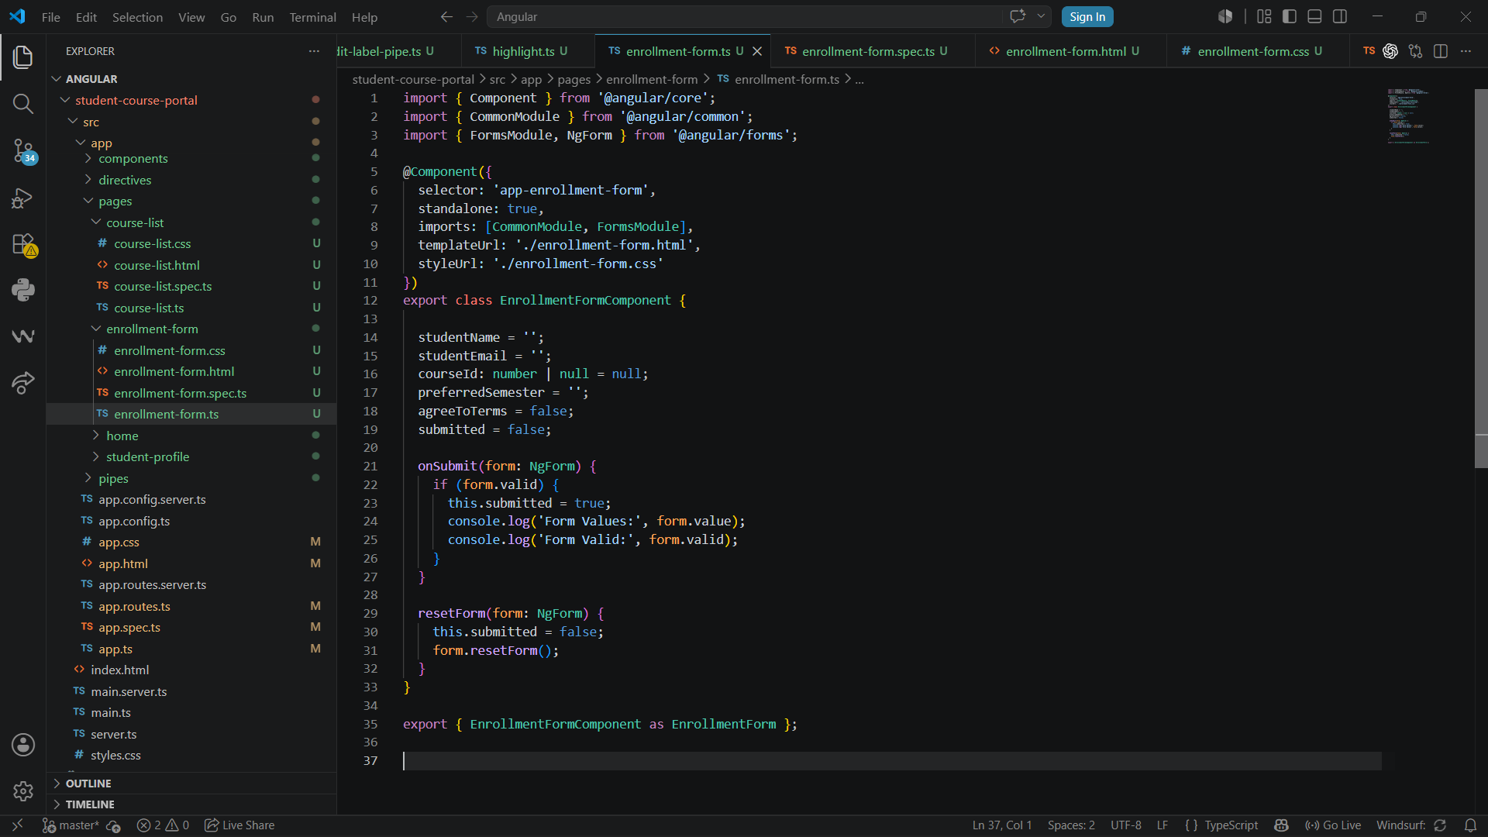

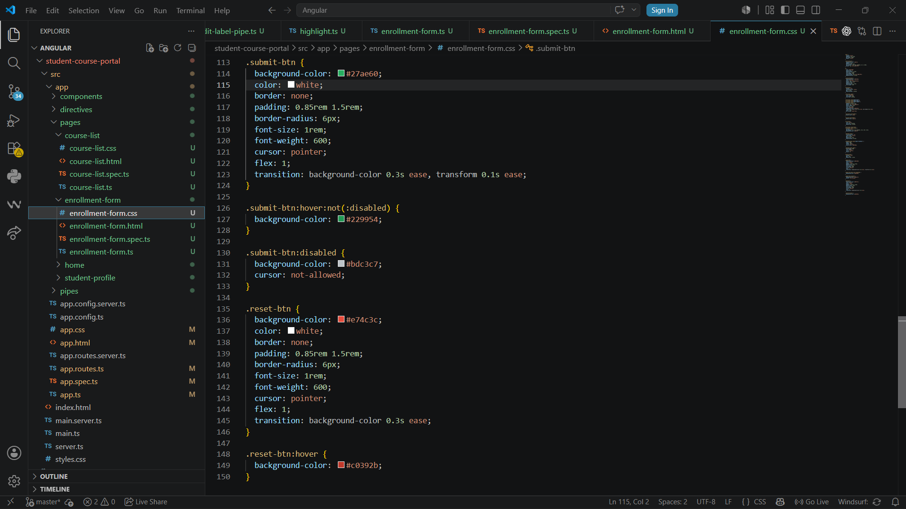

Output:
